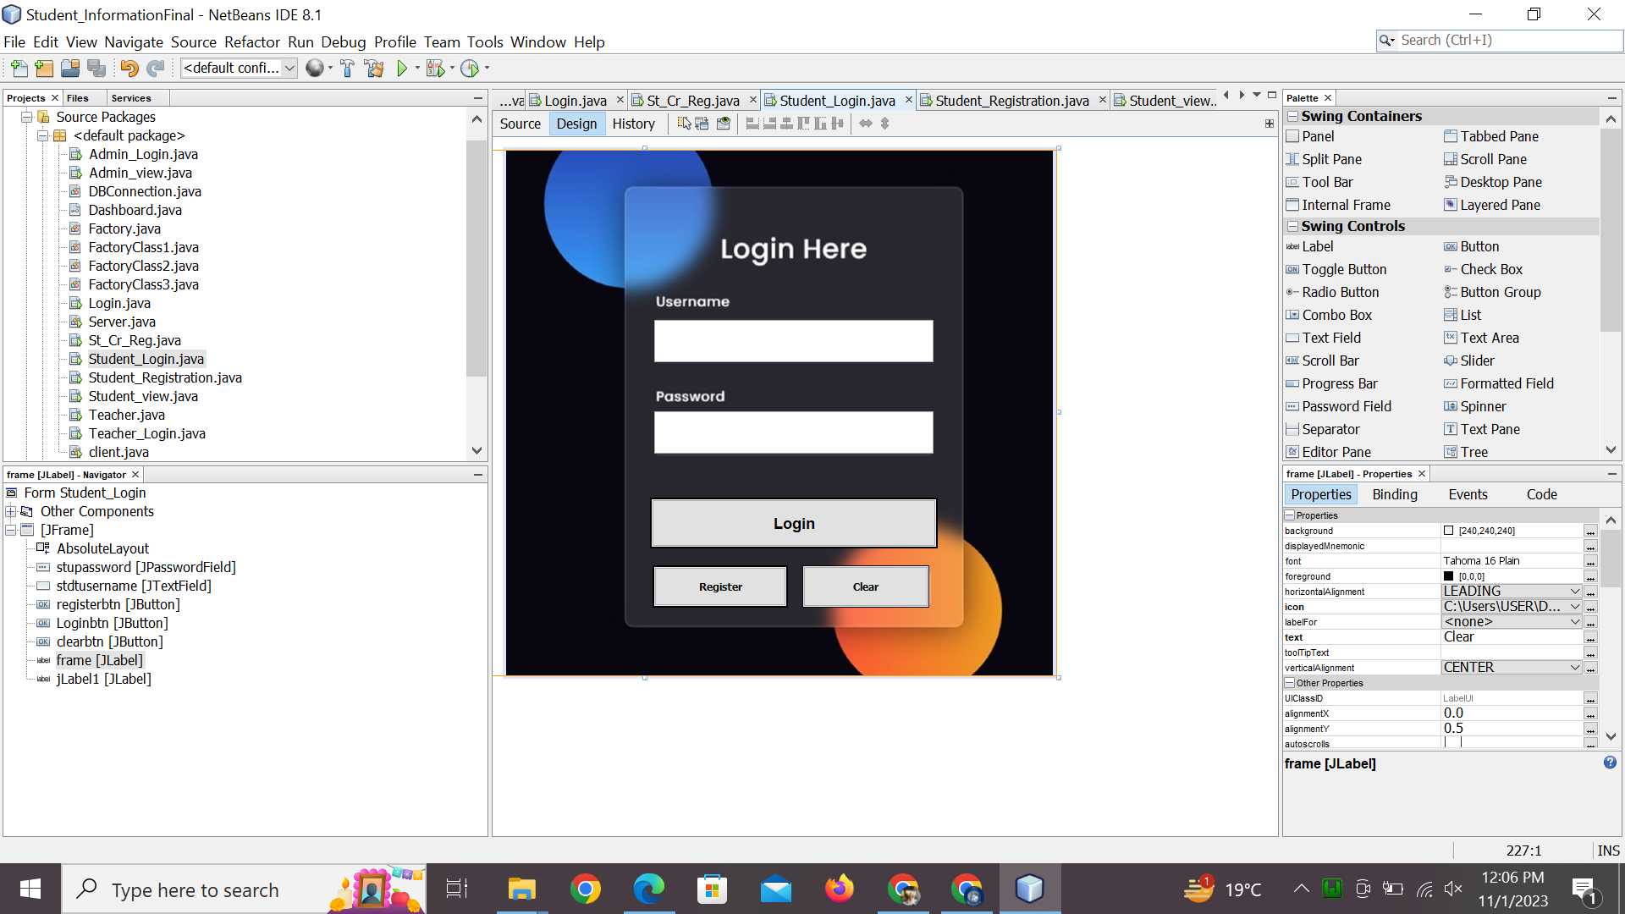

import java.sql.Connection;

import java.sql.ResultSet;

import java.sql.Statement;

import javax.swing.JFrame;

import javax.swing.JOptionPane;

/*

* To change this license header, choose License Headers in Project Properties.

* To change this template file, choose Tools | Templates

* and open the template in the editor.

*/

/**

*

* @author Chaudhry Hammad

*/

public class Student_Login extends javax.swing.JFrame {

Connection con=DBConnection.getDBConnection();

/**

* Creates new form Student_Login

*/

public Student_Login() {

initComponents();

}

/**

* This method is called from within the constructor to initialize the form.

* WARNING: Do NOT modify this code. The content of this method is always

* regenerated by the Form Editor.

*/

@SuppressWarnings("unchecked")

// <editor-fold defaultstate="collapsed" desc="Generated Code">

private void initComponents() {

stupassword = new javax.swing.JPasswordField();

stdtusername = new javax.swing.JTextField();

registerbtn = new javax.swing.JButton();

Loginbtn = new javax.swing.JButton();

clearbtn = new javax.swing.JButton();

frame = new javax.swing.JLabel();

jLabel1 = new javax.swing.JLabel();

setDefaultCloseOperation(javax.swing.WindowConstants.EXIT_ON_CLOSE);

getContentPane().setLayout(new org.netbeans.lib.awtextra.AbsoluteLayout());

stupassword.addActionListener(new java.awt.event.ActionListener() {

public void actionPerformed(java.awt.event.ActionEvent evt) {

stupasswordActionPerformed(evt);

}

});

getContentPane().add(stupassword, new org.netbeans.lib.awtextra.AbsoluteConstraints(175, 308, 330, 50));

stdtusername.addActionListener(new java.awt.event.ActionListener() {

public void actionPerformed(java.awt.event.ActionEvent evt) {

stdtusernameActionPerformed(evt);

}

});

stdtusername.addKeyListener(new java.awt.event.KeyAdapter() {

public void keyTyped(java.awt.event.KeyEvent evt) {

stdtusernameKeyTyped(evt);

}

});

getContentPane().add(stdtusername, new org.netbeans.lib.awtextra.AbsoluteConstraints(175, 200, 330, 50));

registerbtn.setFont(new java.awt.Font("Tahoma", 1, 12)); // NOI18N

registerbtn.setText("Register");

registerbtn.setBorder(javax.swing.BorderFactory.createMatteBorder(2, 2, 2, 2, new java.awt.Color(0, 0, 0)));

registerbtn.addActionListener(new java.awt.event.ActionListener() {

public void actionPerformed(java.awt.event.ActionEvent evt) {

registerbtnActionPerformed(evt);

}

});

getContentPane().add(registerbtn, new org.netbeans.lib.awtextra.AbsoluteConstraints(173, 490, 160, 50));

Loginbtn.setFont(new java.awt.Font("Copperplate Gothic Bold", 1, 18)); // NOI18N

Loginbtn.setText("Login");

Loginbtn.setBorder(javax.swing.BorderFactory.createMatteBorder(2, 2, 2, 2, new java.awt.Color(0, 0, 0)));

Loginbtn.addActionListener(new java.awt.event.ActionListener() {

public void actionPerformed(java.awt.event.ActionEvent evt) {

LoginbtnActionPerformed(evt);

}

});

getContentPane().add(Loginbtn, new org.netbeans.lib.awtextra.AbsoluteConstraints(170, 410, 340, 60));

clearbtn.setFont(new java.awt.Font("Tahoma", 1, 12)); // NOI18N

clearbtn.setText("Clear");

clearbtn.setBorder(javax.swing.BorderFactory.createLineBorder(new java.awt.Color(0, 0, 0)));

clearbtn.addActionListener(new java.awt.event.ActionListener() {

public void actionPerformed(java.awt.event.ActionEvent evt) {

clearbtnActionPerformed(evt);

}

});

getContentPane().add(clearbtn, new org.netbeans.lib.awtextra.AbsoluteConstraints(350, 490, 150, 50));

frame.setIcon(new javax.swing.ImageIcon("C:\\Users\\USER\\Desktop\\pix\\g.jpeg")); // NOI18N

frame.setText("Clear");

getContentPane().add(frame, new org.netbeans.lib.awtextra.AbsoluteConstraints(-320, 0, 970, 620));

jLabel1.setText("jLabel1");

getContentPane().add(jLabel1, new org.netbeans.lib.awtextra.AbsoluteConstraints(0, 0, 650, 620));

pack();

}// </editor-fold>

private void registerbtnActionPerformed(java.awt.event.ActionEvent evt) {

// TODO add your handling code here:

Student_Registration stureg=new Student_Registration();

stureg.setVisible(true);

setVisible(false);

dispose();

}

Runnable r=new Runnable() {

@Override

public void run() {

//To change body of generated methods, choose Tools | Templates.

try{

System.out.println("Thread 2 running");

String username=stdtusername.getText();

String password=stupassword.getText();

Statement stm=con.createStatement();

String sql="select * from student where username='"+username+"' and password='"+password+"'";

ResultSet rs= stm.executeQuery(sql);

if(rs.next()){

// dispose();

Student_view studentview=new Student_view(username);

studentview.setVisible(true);

dispose();

}

else{

JFrame f;

f=new JFrame();

// System.out.println("Invalid username or password");

JOptionPane.showMessageDialog(f,"invalid username or password");

// edtusername.setText("");

// edtpassword.setText("");

}

// con.close();

}

catch(Exception e){

System.out.println(e.getMessage());

}

}

};

Thread t;

private void LoginbtnActionPerformed(java.awt.event.ActionEvent evt) {

// TODO add your handling code here:

t=new Thread(r);

t.start();

// try{

//

// String username=edtusername.getText();

// String password=edtpassword.getText();

//

// Statement stm=con.createStatement();

// String sql="select * from student where username='"+username+"' and password='"+password+"'";

// ResultSet rs= stm.executeQuery(sql);

//

//

// if(rs.next()){

//// dispose();

// Student_view studentview=new Student_view(username);

//

// studentview.setVisible(true);

//

// dispose();

// }

// else{

// JOptionPane.showMessageDialog(this,"invalid id or password");

// edtusername.setText("");

// edtpassword.setText("");

// }

//// con.close();

// }

// catch(Exception e){

// System.out.println(e.getMessage());

// }

}

Runnable r2=new Runnable() {

@Override

public void run() {

// throw new UnsupportedOperationException("Not supported yet."); //To change body of generated methods, choose Tools | Templates.

}

};

private void stdtusernameKeyTyped(java.awt.event.KeyEvent evt) {

// TODO add your handling code here:

char c=evt.getKeyChar();

if(Character.isLetter(c))

{

stdtusername.setEditable(false);

JOptionPane.showMessageDialog(this,"Enter number only");

}

else{

stdtusername.setEditable(true);

}

}

private void stupasswordActionPerformed(java.awt.event.ActionEvent evt) {

// TODO add your handling code here:

}

private void stdtusernameActionPerformed(java.awt.event.ActionEvent evt) {

// TODO add your handling code here:

}

private void clearbtnActionPerformed(java.awt.event.ActionEvent evt) {

// TODO add your handling code here:

stdtusername.setText("");

stupassword.setText("");

}

/**

* @param args the command line arguments

*/

public static void main(String args[]) {

/* Set the Nimbus look and feel */

//<editor-fold defaultstate="collapsed" desc=" Look and feel setting code (optional) ">

/* If Nimbus (introduced in Java SE 6) is not available, stay with the default look and feel.

* For details see http://download.oracle.com/javase/tutorial/uiswing/lookandfeel/plaf.html

*/

try {

for (javax.swing.UIManager.LookAndFeelInfo info : javax.swing.UIManager.getInstalledLookAndFeels()) {

if ("Nimbus".equals(info.getName())) {

javax.swing.UIManager.setLookAndFeel(info.getClassName());

break;

}

}

} catch (ClassNotFoundException ex) {

java.util.logging.Logger.getLogger(Student_Login.class.getName()).log(java.util.logging.Level.SEVERE, null, ex);

} catch (InstantiationException ex) {

java.util.logging.Logger.getLogger(Student_Login.class.getName()).log(java.util.logging.Level.SEVERE, null, ex);

} catch (IllegalAccessException ex) {

java.util.logging.Logger.getLogger(Student_Login.class.getName()).log(java.util.logging.Level.SEVERE, null, ex);

} catch (javax.swing.UnsupportedLookAndFeelException ex) {

java.util.logging.Logger.getLogger(Student_Login.class.getName()).log(java.util.logging.Level.SEVERE, null, ex);

}

//</editor-fold>

/* Create and display the form */

java.awt.EventQueue.invokeLater(new Runnable() {

public void run() {

new Student_Login().setVisible(true);

}

});

}

// Variables declaration - do not modify

private javax.swing.JButton Loginbtn;

private javax.swing.JButton clearbtn;

private javax.swing.JLabel frame;

private javax.swing.JLabel jLabel1;

private javax.swing.JButton registerbtn;

private javax.swing.JTextField stdtusername;

private javax.swing.JPasswordField stupassword;

// End of variables declaration

}